Hello. Thank you for buying my asset.

How to setup?

- Find ClockConfigurationSO scriptable object and choose time format 12 or 24:
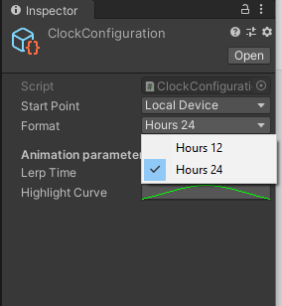
- Success. Now you can use asset.

1) The entry point of this game is:
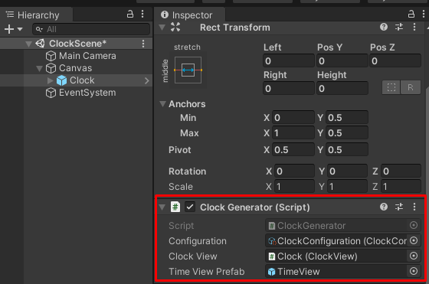
This component generate clock based on configuration parameters.
Asset created on MVC pattern, so you can learn something new for yourself.

For other questions write me an email: support@selvassets.ltd.ua
Thank you for advance!

